1. **Information Security**
2. **Chapter 3: Network Protocols and Services**
4. **Lab 10 - Introduction to Wireshark**

# Mininet Topology

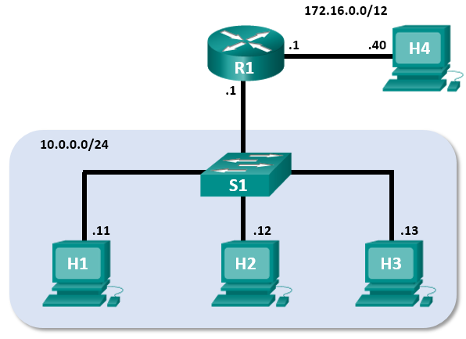

# Objectives

Part 1: Install and Verify the Mininet Topology.

Part 2: Capture and Analyze ICMP Data in Wireshark.

# Background / Scenario

The CyberOps VM includes a Python script that, when you run it, will set up and configure the devices shown in the figure above. You will then have access to four hosts, a switch, and a router inside your one VM. This will allow you to simulate a variety of network protocols and services without having to configure a physical network of devices. For example, in this lab you will use the **ping** command between two hosts in the Mininet Topology and capture those pings with Wireshark.

Wireshark is a software protocol analyzer, or "packet sniffer" application, used for network troubleshooting, analysis, software and protocol development, and education. As data streams travel over the network, the sniffer "captures" each protocol data unit (PDU) and can decode and analyze its content according to the appropriate RFC or other specifications.

Wireshark is a useful tool for anyone working with networks for data analysis and troubleshooting. You will use Wireshark to capture ICMP data packets.

# Required Resources

* CyberOps Workstation virtual machine

# Instructions

## Install and Verify the Mininet Topology

In this part, you will use a Python script to set up the Mininet Topology inside the CyberOps VM. You will then record the IP and MAC addresses for H1 and H2.

### Verify your PC’s interface addresses.

Start and log into your CyberOps Workstation that you have installed in a previous lab using the following credentials:

Username: **analyst** Password: **cyberops**

### Run the Python script to install the Mininet Topology.

Open a terminal emulator to start Mininet and enter the following command at the prompt. When prompted, enter **cyberops** as the password.

[analyst@secOps ~]$ **sudo ~/lab.support.files/scripts/cyberops_topo.py**

[sudo] password for analyst:

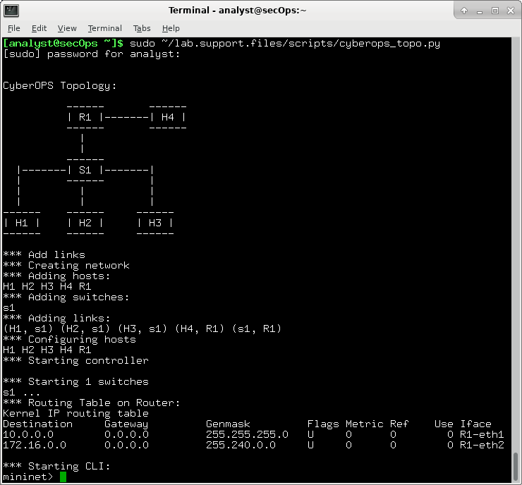

### Record IP and MAC addresses for H1 and H2.

* + 1. At the mininet prompt, start terminal windows on hosts H1 and H2. This will open separate windows for these hosts. Each host will have a separate configuration for the network including unique IP and MAC addresses.

*** Starting CLI:

mininet> **xterm H1**

mininet> **xterm H2**

* + 1. At the prompt on **Node: H1**, enter **ip address** to verify the IPv4 address and record the MAC address. Do the same for **Node: H2**. The IPv4 address and MAC address are highlighted below for reference.

[root@secOps analyst]# **ip address**

<output omitted>

2: H1-eth0@if3: <BROADCAST,MULTICAST,UP,LOWER_UP> mtu 1500 qdisc noqueue state UP group default qlen 1000

link/ether ba:d4:1d:7b:f3:61 brd ff:ff:ff:ff:ff:ff link-netnsid 0

inet 10.0.0.11/24 brd 10.0.0.255 scope global H1-eth0

valid_lft forever preferred_lft forever

inet6 fe80::b8d4:1dff:fe7b:f361/64 scope link

valid_lft forever preferred_lft forever

|  |  |  |
| --- | --- | --- |
| Host-interface | IP Address | MAC Address |
| H1-eth0 | 10.0.0.11/24 | c2:89:1f:b1:40:21 |
| H2-eth0 | 10.0.0.12/24 | ee:11:73:7f:b6:ca |

## Capture and Analyze ICMP Data in Wireshark

In this part, you will ping between two hosts in the Mininet and capture ICMP requests and replies in Wireshark. You will also look inside the captured PDUs for specific information. This analysis should help to clarify how packet headers are used to transport data to the destination.

### Examine the captured data on the same LAN.

In this step, you will examine the data that was generated by the ping requests of your team member’s PC. Wireshark data is displayed in three sections:

* The top section displays the list of PDU frames captured with a summary of the IP packet information listed.
* The middle section lists PDU information for the frame selected in the top part of the screen and separates a captured PDU frame by its protocol layers.
* The bottom section displays the raw data of each layer. The raw data is displayed in both hexadecimal and decimal form.

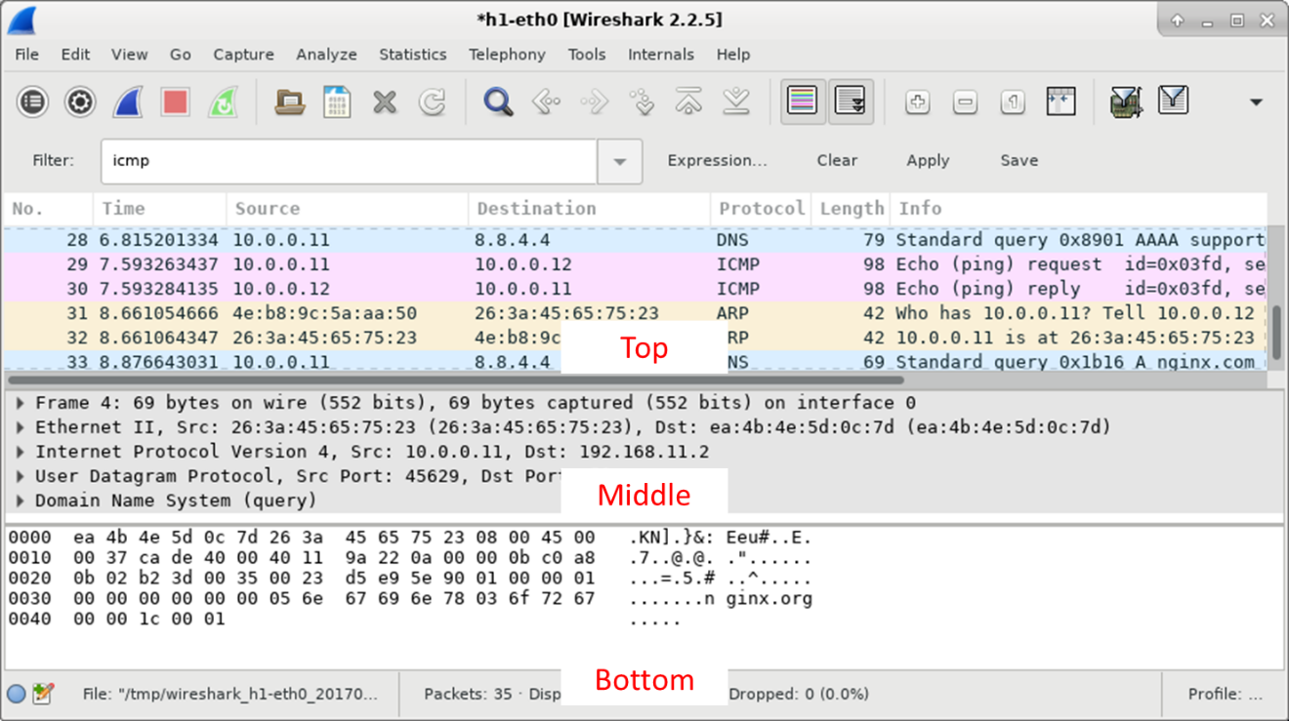

* + - 1. On **Node: H1**, enter **wireshark &** to start Wireshark (The pop-up warning is not important for this lab.). Click **OK** to continue.

[root@secOps]# **wireshark &**

[1] 1552

[root@secOps ~]#

** (wireshark:1552): WARNING **: Couldn't connect to accessibility bus: Failed to connect to socket /tmp/dbus-f0dFz9baYA: Connection refused

Gtk-Message: GtkDialog mapped without a transient parent. This is discouraged.

* + - 1. In the Wireshark window, under the **Capture** heading, select the **H1-eth0** interface. Click **Start** to capture the data traffic.

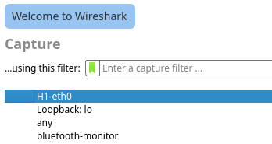

* + - 1. On **Node: H1**, press the Enter key, if necessary, to get a prompt. Then type **ping -c 5 10.0.0.12** to ping H2 five times. The command option **-c** specifies the count or number of pings. The **5** specifies that five pings should be sent. The pings will all be successful.

[root@secOps analyst]# **ping -c 5 10.0.0.12**

* + - 1. Navigate to the Wireshark window, click **Stop** to stop the packet capture.
      2. A filter can be applied to display only the interested traffic.

Type **icmp** in the **Filter** field and click **Apply**.

* + - 1. If necessary, click the first ICMP request PDU frames in the top section of Wireshark. Notice that the Source column has H1’s IP address, and the Destination column has H2’s IP address.

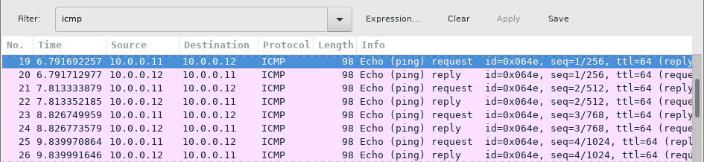

* + - 1. With this PDU frame still selected in the top section, navigate to the middle section. Click the arrow to the left of the Ethernet II row to view the Destination and Source MAC addresses.

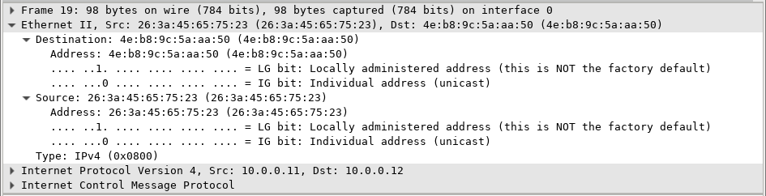

#### Question:

Does the Source MAC address match H1’s interface?

Ans: Yes

Does the Destination MAC address in Wireshark match H2’s MAC address?

Ans: Yes

**Note**: In the preceding example of a captured ICMP request, ICMP data is encapsulated inside an IPv4 packet PDU (IPv4 header) which is then encapsulated in an Ethernet II frame PDU (Ethernet II header) for transmission on the LAN.

### Examine the captured data on the remote LAN.

You will ping remote hosts (hosts not on the LAN) and examine the generated data from those pings. You will then determine what is different about this data from the data examined in Part 1.

* + - 1. At the mininet prompt, start terminal windows on hosts H4 and R1.

mininet> **xterm H4**

mininet> **xterm R1**

* + - 1. At the prompt on **Node: H4**, enter **ip address** to verify the IPv4 address and record the MAC address. Do the same for the **Node: R1**.

[root@secOps analyst]# **ip address**

|  |  |  |
| --- | --- | --- |
| Host-interface | IP Address | MAC Address |
| H4-eth0 | 172.16.0.40/12 | 12:8f:41:d0:b9:55 |
| R1-eth1 | 10.0.0.1/24 | d6.:9c:63:ff:0b:08 |
| R1-eth2 | 172.16.0.1/12 | 32:01:c0:8e:83:94 |

* + - 1. Start a new Wireshark capture on H1 by selecting **Capture > Start**. You can also click the **Start** button or type **Ctrl-E** Click **Continue without Saving** to start a new capture.
      2. H4 is a simulated remote server. Ping H4 from H1. The ping should be successful.

[root@secOps analyst]# **ping -c 5 172.16.0.40**

* + - 1. Review the captured data in Wireshark. Examine the IP and MAC addresses that you pinged. Notice that the MAC address is for the R1-eth1 interface. List the destination IP and MAC addresses.

#### Question:

IP address:

Ans: 172.16.0.40

MAC address:

Ans: d6:9c:63:ff:0b:08

* + - 1. In the main CyberOps VM window, enter **quit** to stop Mininet.

mininet> **quit**

*** Stopping 0 controllers

*** Stopping 4 terms

*** Stopping 5 links

.....

*** Stopping 1 switches

s1

*** Stopping 5 hosts

H1 H2 H3 H4 R1

*** Done

* + - 1. To clean up all the processes that were used by Mininet, enter the **sudo mn -c** command at the prompt.

analyst@secOps ~]$ **sudo mn -c**

[sudo] password for analyst:

*** Removing excess controllers/ofprotocols/ofdatapaths/pings/noxes

killall controller ofprotocol ofdatapath ping nox_core lt-nox_core ovs-openflowd ovs-controller udpbwtest mnexec ivs 2> /dev/null

killall -9 controller ofprotocol ofdatapath ping nox_core lt-nox_core ovs-openflowd ovs-controller udpbwtest mnexec ivs 2> /dev/null

pkill -9 -f "sudo mnexec"

*** Removing junk from /tmp

rm -f /tmp/vconn* /tmp/vlogs* /tmp/*.out /tmp/*.log

*** Removing old X11 tunnels

*** Removing excess kernel datapaths

ps ax | egrep -o 'dp[0-9]+' | sed 's/dp/nl:/'

*** Removing OVS datapaths

ovs-vsctl --timeout=1 list-br

ovs-vsctl --timeout=1 list-br

*** Removing all links of the pattern foo-ethX

ip link show | egrep -o '([-_.[:alnum:]]+-eth[[:digit:]]+)'

ip link show

*** Killing stale mininet node processes

pkill -9 -f mininet:

*** Shutting down stale tunnels

pkill -9 -f Tunnel=Ethernet

pkill -9 -f .ssh/mn

rm -f ~/.ssh/mn/*

*** Cleanup complete.